**28th January 2026**

**Assignment Report**

Name of the website- **Frost & Form**

Top of the website-**online winter clothing store.**

**About Website**

The website is an Online Clothing Store called “Frost and Form”. It focuses on selling three main items: sweaters, boots, and jackets and for cold weather. In addition, it focuses on selling trendy clothes and everyday essentials for people who want to look good without overthinking it.

It specializes in high-quality design for both style and protection against the weather (cold and rain). The goal of the site is to display products clearly, make browsing easy, and encourage users to purchase online.

**Target Audience**

Anyone who values quality clothes that look good on social media but also actually keep them warm in real life. People who live in cold cities and need a stylish jacket, sweater and boots for commuting and those who like weekend trips, hiking, or autumn walks as well.

The users who look for “outfit inspiration” on social media and want to buy a whole look (sweater, boots and jacket together). Therefore, they want to shop quickly on their mobile phones and have things delivered fast.

**Website look and feel**

The look is clean and cozy. The design is simple with big pictures of the products so users can see the material of the sweater, jacket and the details on the boot easily. Modern clothing websites focus on large, high-quality photos and lots of white space. Most users will shop on their phones, so the site must look like a clean, scrollable app. We don't crowd the screen. By leaving lots of white space around the products, the website looks clean and organized. This makes it much easier for customers to focus on the clothes without getting distracted.

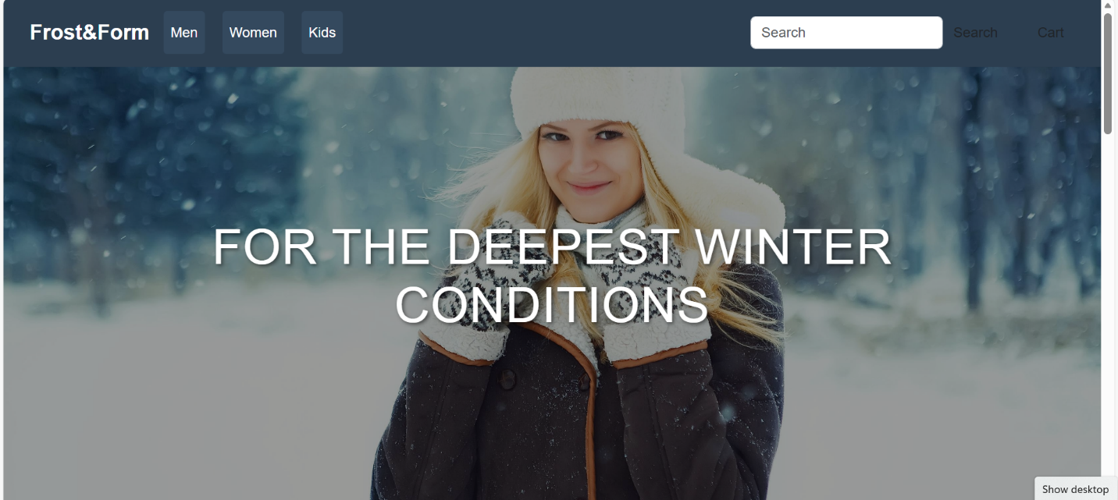

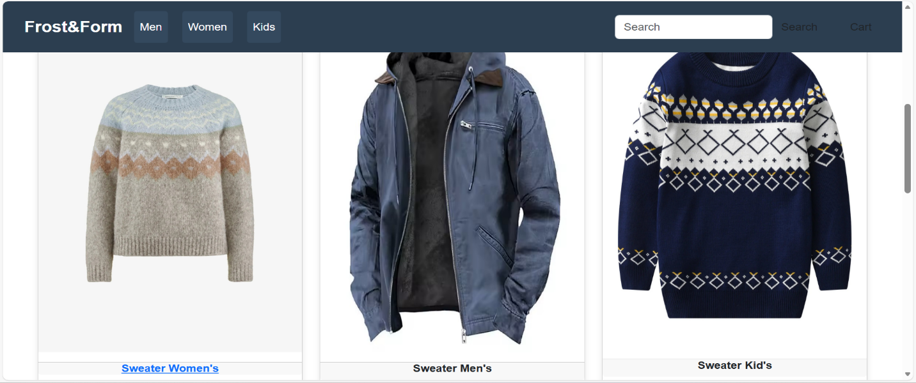

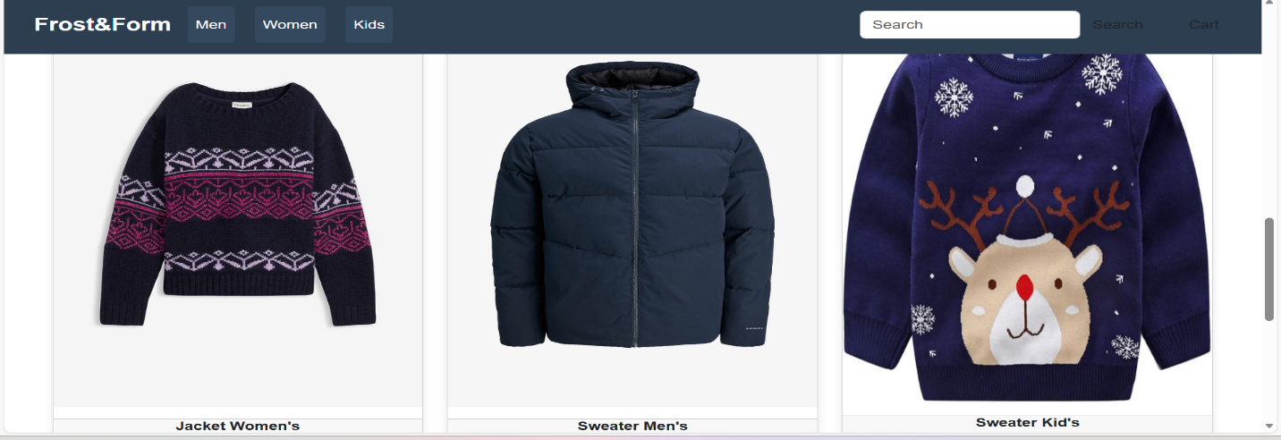

**Current competitor to the business.**

**Timberland**: Great for seeing how to display boots in rugged, outdoor settings.

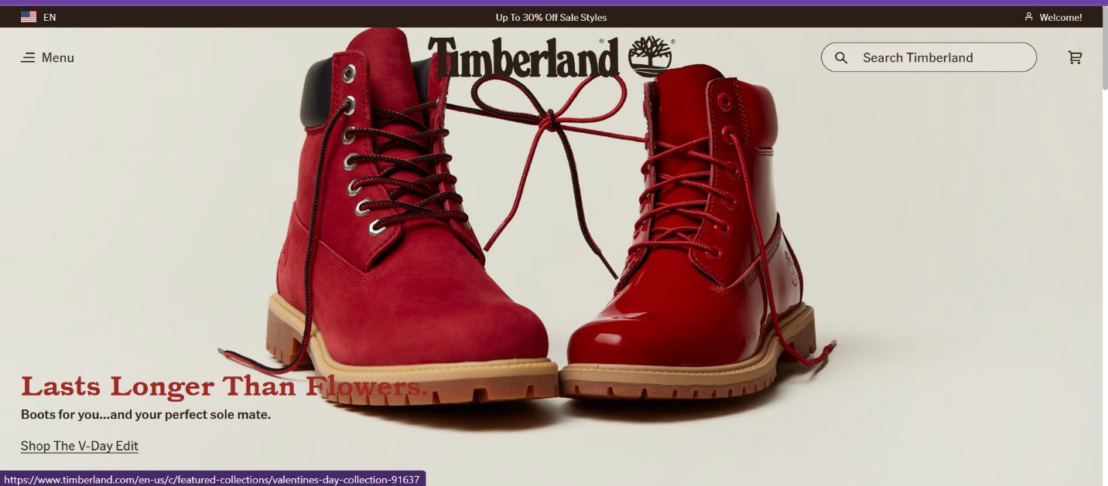

**The North Face**: Perfect for jackets. They use technical callouts (small icons) to show if a jacket is waterproof or windproof.

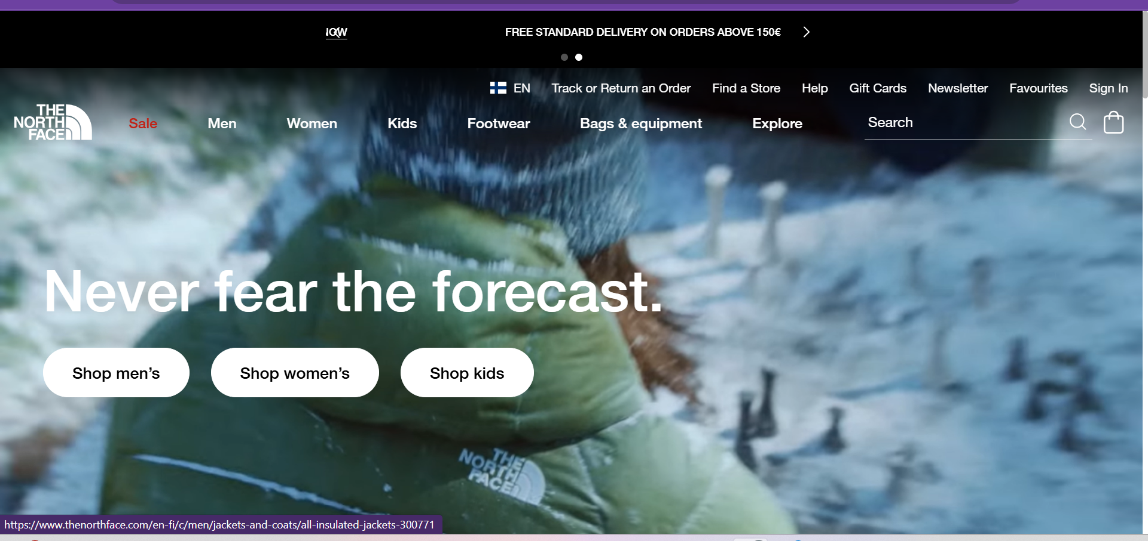

**Zara**: Excellent examples of sweaters. They use clean, minimalist layouts that make clothes look high-end and expensive.

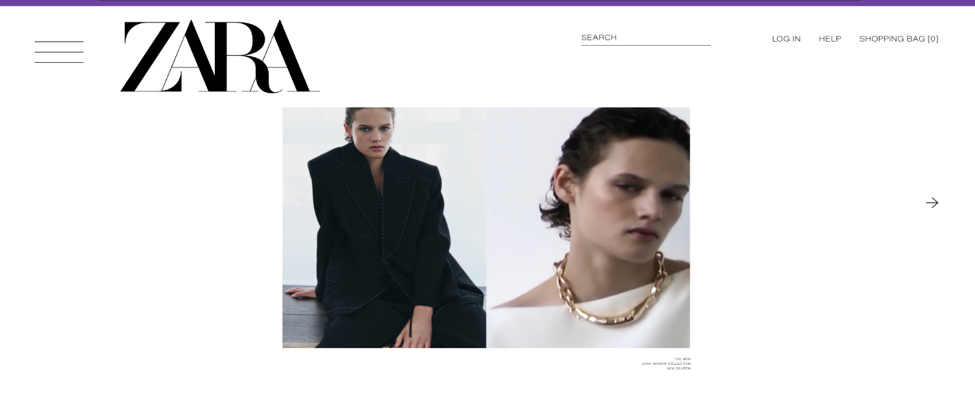

**Color palate.**

We used following color to design the website

**Color RGB Usage**

White (255, 255, 255) Background, cards, product image

Dark Blue (44, 62, 80) Product names, collection info headings

Black (0, 0, 0) Product prices, tagline text

Light Gray (238, 238, 238) Footer border

Text Gray (127, 140, 141) Footer text

**We use a very simple color palette to feel like snow and winter.**

# **Team Members and Contributions.**

1. Putnaite Aurelija -Team Leader

* Planning the project
* Draw project lay out
* Apply bootstrap.

2. Wanninayaka Thushara

* Design the webpages (CSS)

3 Sushant

* Creating the ages (HTML)

**Web link of website- https://kareivukas.github.io/Clothing-store/index.html**

End